Parent/Guardian/Student Permission to Record
Valid for the 2024-25 School Year

Dear Parent/Guardian:
I am a student teacher at Corban University, participating in a Teacher Candidate Performance Assessment (TCPA) to fulfill a requirement for my institution and/or a state certification requirement. TCPA is a teacher performance assessment for teacher candidates created by Corban University and approved by Teacher Standards and Practices of Oregon. My materials will be submitted to and scored by educators in a secure system by Go React which encrypts data both in transmission and at rest.
The performance assessment documents a series of lessons I teach in your child’s classroom and includes short video recording. Although the video recordings involve both the teacher and various students; the primary focus is on my instruction, not on the students in the class. While recording my teaching, your child may appear on the video. Also, I will collect samples of student work as evidence of my teaching practice, and that may include some of your child’s work
No student’s name will appear on any materials that are submitted, and materials will always be kept confidential and secure. The video recordings and student work I submit will not be made public in any way. Materials I submit will only be reviewed by my program at Corban University.

Sincerely,

_______________________________________________
(Teacher Candidate Signature)

Student Release Form
(to be completed either by the parents/legal guardians of minor students involved in this or by students who are 18 or more years of age involved in this project)
PERMISSION SLIP
Student Name: __________________________
I am the parent/legal guardian of the child named above. I have read and understand the project description given in the letter provided with this form, and agree to the following:
(please check the appropriate box below)
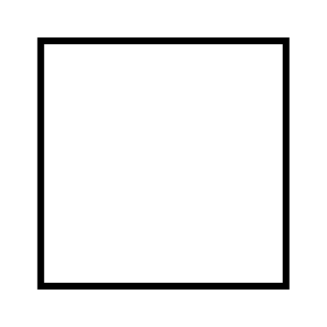 I DO give permission to you to include my child’s student work and/or image on video(s) recordings as part of your classroom performance, to be used for the purpose of participating in the TCPA.
I understand that my child’s name and any other personally identifiable information about my child will not appear on any of the submitted materials.
I DO NOT give permission to you to include my child’s student work and/or image on video(s) recordings as part of your classroom performance, to be used for the purpose of participating in the TCPA.
Signature of Parent/Guardian: ______________________________________________ Date: ___________

I am the student named above and am more than 18 years of age. I have read and understand the project description and given in the letter provided with this from and agree to the following:
I DO give permission to you to include my student work and/or image on video(s) recordings as part of your classroom performance, to be used for the purpose of participating in the TCPA.
I understand that my name and any other personally identifiable information about my child will not appear on any of the submitted materials.
I DO NOT give permission to you to include my student work and/or image on video(s) recordings as part of your classroom performance, to be used for the purpose of participating in the TCPA.
Signature of Student: ______________________________________________ Date: ___________
Date of Birth: ____/____/_____
MM DD YY

